

**Mini Project Report**

On Blogster

### Submitted By:

#### Mani Bansal (C/181500364)

Prachi Bansal (C/181500459)

Rajni Bhardwaj(D/1815005 49)

Kishori Tiwari(D/181500327)

Department of Computer Engineering & Applications

**Institute of Engineering & Technology**





**GLA University Mathura- 281406, INDIA**

Certificates

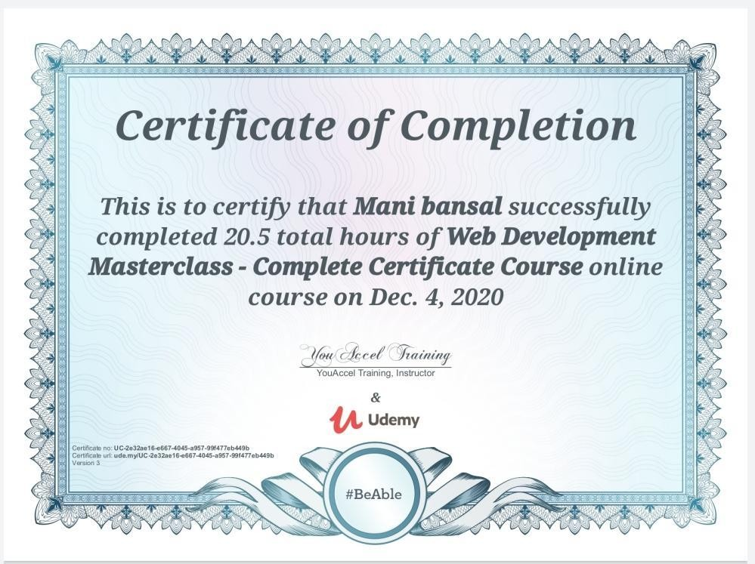



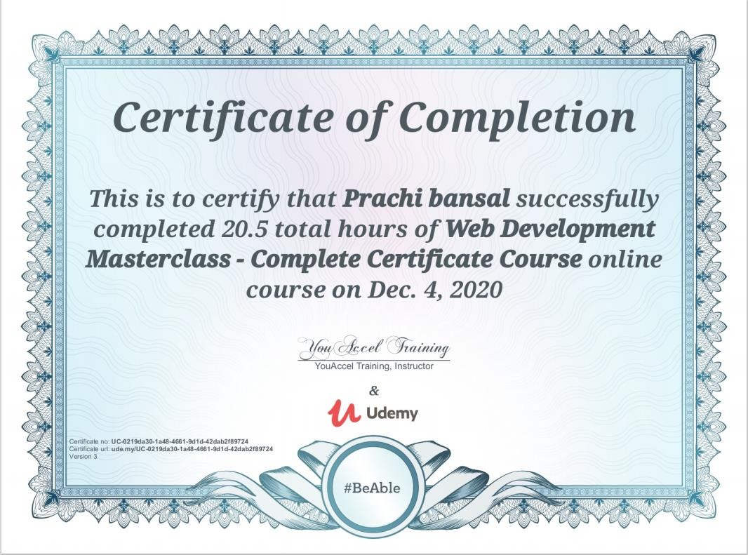





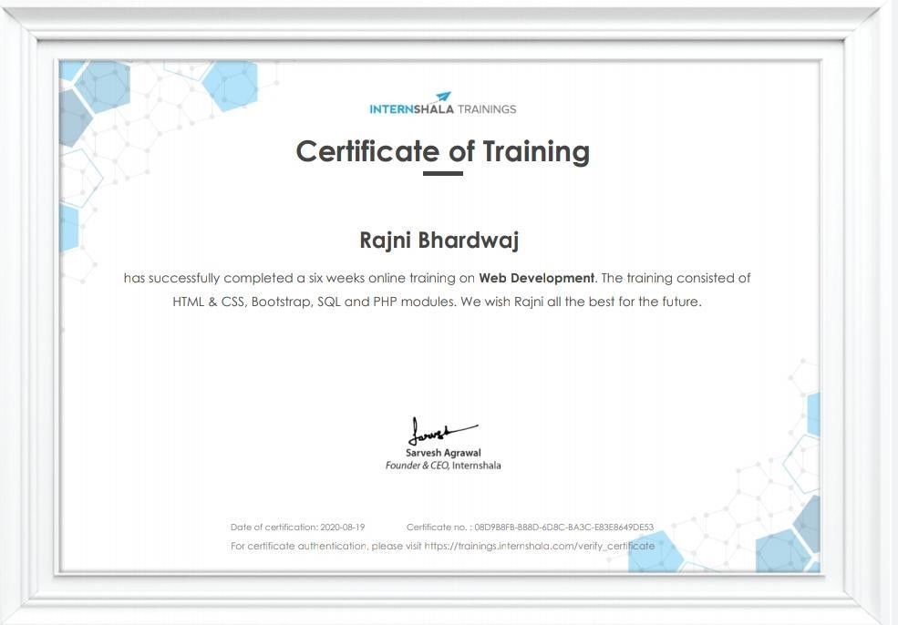



**FULL-STACK PROJECT SYNOPSIS**

### PROJECT TOPIC: Blog Content Management Website

##### Submitted By:

1. Rajni Bhardwaj (D/181500549)

**2.** Mani Bansal (C/181500364)

1. Prachi Bansal (C/181500459)
2. Kishori Tiwari (D/181500327)

**Project Supervisor:** Mr. Pankaj Kapoor (Assistant Professor/Associate Professor) GLA University, Mathura

**Department of Computer Engineering and Applications Institute of Engineering & Technology**

https://lh4.googleusercontent.com/-7NPHzoVzwsdIcAuD3KPZKaj8-64d_JjpqsNqu6Vt3qI1RFora_dhTFfT66AW8GERlDInYDl2cezHdLJyGQJpbsofE-9pnS8dQdIFEeGNHwvXg6onJ4OKlXd1ptnuTiZT580OlTk

**Problem Statement:**

**GLA University Mathura- 281406**

Blogging provides anyone with the opportunity to publish content and the potential to make money. Because of this, there are hundreds or thousands of new blogs launched every day. Unfortunately, there are some significant challenges that most new bloggers face, and in many cases the challenges are significant enough to lead the blogger to give up. In order to contribute in its solution we have decided to create a Blog Content Management System.



**About the Project:**

The blog Content Management has been developed to override the problems prevailing in the practicing manual system. Every organization, whether big or small, has challenges to overcome and manage the information of Idea, Blogs, Content, Entries and Views. Also for those busy executives who are always on the go, our systems come with remote features, which will allow you to manage your workforce anytime, at all times. These Systems will ultimately allow you to better manage resources.

**Objective:**

The Main objective of the project is to manage the details of Blogs, Topic, Idea, Content, Entries. It manages all the information about the Blogs, Views, Entries, and Blogs. The purpose of the project is to build an application program to reduce the manual work for managing the Blogs, Ideas, Content and Topic. It tracks all the details about the Topic, Entries and Views.

**Future Scope:**

In a nutshell, it can be summarized that the future Scope of the project around maintaining information regarding:

* We will host the platform on online servers to make it accessible worldwide. ● Create the master and slave database structure to reduce the overload of the database queries.
* We can give more advanced software for Blog Content Management including more facilities.
* Implement the backup mechanism for taking backup of codebase and database on a regular basis on different servers.

**Methodology:**

* The planning stage
* The analysis stage is the most critical stage, and concerns the content of information and the attractiveness of web application design. It analyses and examines the requirements to produce a complete website (Front-End) throughout the development life cycle. This is to ensure that the web-based information is feasible to be developed.
* The design stage provides a ‘skeleton’ to the web-based information where it describes how such a website is to be designed. All necessary design specifications are developed including interface design.
* The implementation stage involves constructing interfaces and implementing codes according to design specifications. The actual program codes that are written may conform to the web standards testing the web-based information systems for quality assurance is also required and must take into consideration the nature of the web.
* The maintenance stage ensures the content of the web-based information systems is dynamically updated and made continuously reliable by reviewing and maintaining the systems.





29/4/20

18/6/20

7/8/20

26/9/20

15/11/20

4/1/21

Goal Identification

Synopsis Submission

Planning

Analysis

Design

Implementation

\***Gantt Chart\***

**TOOLS REQUIRED:**

**Hardware Requirements:**

* + Processor Pentium||||630MHz
  + RAM 128 MB
  + Hard Disk 20 GB
  + Monitor 15'' color monitor
  + Keyboard 122 keys

**Software Requirements:**

* VSCodeUserSetup-x64-1.45.1
* Web browser

**Technology to be used:**

* + HTML5,
  + CSS3,
  + JavaScript
  + Bootstrap



**Online GIT Repository:**

FULLSTACK_PROJECT_Blog

**Conclusion:**

The project is based on a blog content management on web page designing which is a knowledgeable project for the students. A blog is an opportunity to inspire people and make them see how great your brain is. You should leave your readers energized and leaping out of their chairs, ready to move mountains, make big decisions, or at least try something new. Since the advent of blogs, the number of online journals has significantly increased worldwide. Private Bloggers write down their own thoughts and share their ideas and experiences with their readers. We hope the blogging industry will become more diverse with time**.** In particular, we would love to see more representation on this survey in years to come from people of many different ethnicities and countries of origin. In that diversity, the blogging industry will gain perspective and richness that it would otherwise lack and we will all be better for it.

**References:**

* **https://en.wikipedia.org/wiki/Blog**
* **https:/**[**/www**](http://www.w3schools.com/)**.**[**w3schools.com/**](http://www.w3schools.com/)
* **https://code.makery.ch/library/html-css/part5/**
* **https:/**[**/www**](http://www.beta-labs.in/2020/06/web-development.html)**.**[**beta-labs.in/2020/06/web-development.html**](http://www.beta-labs.in/2020/06/web-development.html)



**ACKNOWLEDGEMENT**

The project work in this report is an outcome of continuous work over a period and drew intellectual support from various sources. We would like to articulate our profound gratitude to all those people who extended their wholehearted co- operation and have helped us in completing this project successfully.

We are thankful to our mentor **Pankaj Kapoor** for teaching and assisting us in making the project successful. We would also like to thank other fellow mates for guiding and encouraging us throughout the duration of the project.

We would also like to thank the teaching staff for their constant encouragement, support and guidance which helped us in successfully completing the project work.

**Mani Bansal Prachi Bansal Rajni Bhardwaj Kishori Tiwari**





**ABSTRACT**

Blogging has become such a mania that a new blog is being created every second of every minute of every hour of every day. A blog is your best bet for a voice among the online crowd .Blogs were usually the work of a single individual occasionally of a small group, and often covered a single subject .More recently, “multi-author blogs” have developed, with posts written by large numbers of authors and professionally edited.

Blog can also be used as a verb ,meaning to maintain or add content to a blog.

WEBLOG is a combination of both Blog as well as Novels .Blog contain the Information of various things related to Technology ,Education ,News ,International ,Business ,Sports, Entertainment and ongoing college activities.

The main aim of this project is to provide data to students in only one site.

Students can gather the information from one site as well as

give their feedback and create their own blog. Students can post their views and thoughts and analyze themselves.

Besides all such core functionalities ,the application also includes features like FAQ ,request, feedback etc. so as to provide a satisfactory user experience.



**Table of Contents**

Certificates Acknowledgment Abstract

**Chapter 1: Introduction**

* 1. Overview
  2. Why we choose this project
  3. Motivation
  4. Objective
  5. Future Scope

**Chapter 2: System Design and Methodology**

* 1. System Module
     1. User in this module
     2. Admin in this module
  2. Methodology
  3. Implementation Requirements
     1. Hardware Requirements
     2. Software Requirements
  4. Maintenance

**Chapter 3: Tools and Technology**

* 1. Technologies used



* + 1. HTML
    2. CSS
    3. Javascript
    4. Bootstrap

**Chapter 4: Result and Conclusion**

References



**CHAPTER - 1**

**INTRODUCTION**

* 1. **Overview**

Blogging is a powerful semantic publishing platform, and it comes with a great set of features designed to make your experience as a publisher on the Internet as easy, pleasant and appealing as possible.

Blogging is often seen as a good way to get in touch with students. This blog is a type of website that consists of entries either made by the students or other members. A blog is a great way for a person to learn how to create their own website.

As specialized content management systems, weblog applications support the editing, and publishing of blog posts. Blog contain the Information of various things related to Technology, Education, News, International, Business, Sports, Entertainment and ongoing college activities.

The main aim of this project is to provide data to students in only one site. Students can gather the information from one site as well as give their feedback and create their own blog. Students can post their views and thoughts and analyze themselves.

# Why we choose this project

In recent past time Blogs are store in the paper files and difficult to search or modify any information, for expanding the Blogs infrastructure, Awareness of environmental issues or any other issues related to education, health, digital technology, and search for greater safety give to information to all persons in all age groups and a new role within the education system, I choose this project. As a result of these project initiatives phenomenal growth has taken place in all the activities of blogs and any user can share its information related to any topic to all users.



# Motivation

Existing system is a manual system. It requires a lot of file work to be done. It is a time consuming system. All customer information is maintained manually . Any searching requires so much effort manually.

There is no way of spreading the information so fast and in the cheapest manner. In previous system all information does not get in one place. Here people can write whatever they want to write.

* 1. **Objective**

The Main objective of the project is to manage the details of Blogs,Topic,Idea,Content,Entries.It manages all the information about the Blogs,Views,Entries, Blogs. The purpose of the project is to build an application program to reduce the manual work for managing the Blogs, Ideas, Content and Topic.It tracks all the details about the Topic, Entries and Views.

# Future Scope

In a nutshell,it can be summarized that the future Scope of the project around maintaining information regarding:

* + - We will host the platform on online servers to make it accessible worldwide.
    - Create the master and slave database structure to reduce the overload of the database queries.
    - We can give more advanced software for Blog Content Management including more facilities.
    - Implement the backup mechanism for taking backup of codebase and database on a regular basis on different servers.



**CHAPTER - 2**

**SYSTEM MODULE AND METHODOLOGY**

This chapter discusses the architecture, various hardware and software requirements and challenges of the project.

# System Module

The modules involved in this project are

* + 1. User
    2. Admin

### User in this module:

* + - * User can sign up
      * User can login
      * User can add information
      * User can add comments
      * User can select any categories

### Admin in this module:

* + - * Admin can see all pages
      * Admin can maintain all records of user
      * Admin provide all information related to any topic
      * Admin can delete/update/select users

# Methodology

* The planning stage
* The analysis stage is the most critical stage, and concerns the content of information and the attractiveness of web application design. It analyses and examines the requirements to produce a complete website (Front-End) throughout the development life cycle.This is to ensure that the web- based information is feasible to be developed.
* The design stage provides a ‘skeleton’ to the web-based information where it describes how such a website is to be designed. All necessary design specifications are developed including interface design.
* The implementation stage involves constructing interfaces and implementing codes according to design specifications. The actual program codes that are written may conform to the web standards Testing the web-based information systems for quality assurance is also required and must take into consideration the nature of the web.
* The maintenance stage ensures the content of the web-based information systems is dynamically updated and made continuously reliable by reviewing and maintaining the systems.



# Implementation Requirements

In this section we will discuss about the various hardware and software requirements

* + 1. **Hardware Requirements:**
       - Processor Pentium||||630MHz
       - RAM. 128 Mbhn
       - Hard Disk. 20GB
       - Monitor. 15'' color monitor
* Keyboard 122 keys
  + 1. **Software Requirements:**
       - VSCodeUserSetup-x64-1.45.1
       - Web browser

# Maintenance

The website involves following Maintenance processes

* Manage Post
* Manage Topics
* Manage User



**CHAPTER-3**

**TOOLS AND TECHNOLOGY**

* 1. **Technologies used :** HTML, CSS, Javascript, Bootstrap

### HTML

HTML is the standard markup language for creating Web pages.

**What is HTML?**

* + - 1. HTML stands for Hyper Text Markup Language
      2. HTML is the standard markup language for creating Web pages
      3. HTML describes the structure of a Web page
      4. HTML consists of a series of elements
      5. HTML elements tell the browser how to display the content
      6. HTML elements label pieces of content such as "this is a heading", "this is a paragraph", "this is a link", etc.

### HTML Element

An HTML element is defined by a start tag, some content, and an end tag:

<tagname>Content goes here...</tagname>

The HTML element is everything from the start tag to the end tag:

<h1>My First Heading</h1>



<p>My first paragraph.</p>

### HTML Documents

All HTML documents must start with a document type declaration: <!DOCTYPE html>.

The HTML document itself begins with <html> and ends with </html>.

The visible part of the HTML document is between <body> and </body>.

* + 1. **CSS**

### What is CSS?

* CSS stands for Cascading Style Sheets
* CSS describes how HTML elements are to be displayed on screen, paper, or in other media
* CSS saves a lot of work. It can control the layout of multiple web pages all at once
* External stylesheets are stored in CSS files

## CSS Syntax

A CSS rule-set consists of a selector and a declaration block:

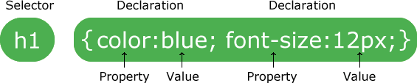



* The selector points to the HTML element you want to style.
* The declaration block contains one or more declarations separated by semicolons.
* Each declaration includes a CSS property name and a value, separated by a colon.
* Multiple CSS declarations are separated with semicolons, and declaration blocks are surrounded by curly braces.

## CSS Selectors

CSS selectors are used to "find" (or select) the HTML elements you want to style. We can divide CSS selectors into five categories:

* Simple selectors (select elements based on name, id, class)
* [Combinator selectors](https://www.w3schools.com/css/css_combinators.asp) (select elements based on a specific relationship between them)
* [Pseudo-class selectors](https://www.w3schools.com/css/css_pseudo_classes.asp) (select elements based on a certain state)
* [Pseudo-elements selectors](https://www.w3schools.com/css/css_pseudo_elements.asp) (select and style a part of an element)
* [Attribute selectors](https://www.w3schools.com/css/css_attribute_selectors.asp) (select elements based on an attribute or attribute value)

## Javascript

* JavaScript is the world's most popular programming language.
* JavaScript is the programming language of the Web.
* JavaScript is easy to learn.

### JavaScript Can Change HTML Content

One of many JavaScript HTML methods is getElementById().

The example below "finds" an HTML element (with id="demo"), and changes the element content (innerHTML) to "Hello JavaScript":

Example



document.getElementById("demo").innerHTML = "Hello JavaScript";

### JavaScript Values

The JavaScript syntax defines two types of values:

* Fixed values
* Variable values

Fixed values are called Literals. Variable values are called Variables.

### JavaScript Literals

The two most important syntax rules for fixed values are:

1. Numbers are written with or without decimals
2. Strings are text, written within double or single quotes

### JavaScript Variables

In a programming language, variables are used to store data values.

JavaScript uses the var keyword to declare variables. An equal sign is used to assign values to variables.

### Bootstrap

Bootstrap is the most popular HTML, CSS, and JavaScript framework for developing responsive, mobile- first websites.

### What is Bootstrap?



* Bootstrap is a free front-end framework for faster and easier web development
* Bootstrap includes HTML and CSS based design templates for typography, forms, buttons, tables, navigation, modals, image carousels and many other, as well as optional JavaScript plugins
* Bootstrap also gives you the ability to easily create responsive designs

### Why Use Bootstrap?

Advantages of Bootstrap:

* Easy to use: Anybody with just basic knowledge of HTML and CSS can start using Bootstrap
* Responsive features: Bootstrap's responsive CSS adjusts to phones, tablets, and desktops
* Mobile-first approach: In Bootstrap 3, mobile-first styles are part of the core framework
* Browser compatibility: Bootstrap is compatible with all modern browsers (Chrome, Firefox, Internet Explorer, Edge, Safari, and Opera)

### Bootstrap Grid System

* Bootstrap's grid system allows up to 12 columns across the page.
* Bootstrap's grid system is responsive, and the columns will re-arrange automatically depending on the screen size.







### Grid Classes

The Bootstrap grid system has four classes:

* xs (for phones - screens less than 768px wide)
* sm (for tablets - screens equal to or greater than 768px wide)
* md (for small laptops - screens equal to or greater than 992px wide)
* lg (for laptops and desktops - screens equal to or greater than 1200px wide)

### Basic Structure of a Bootstrap Grid

The following is a basic structure of a Bootstrap grid:

<div class="row">

<div class="col-*-*"></div>

<div class="col-*-*"></div>

</div>



<div class="row">

<div class="col-*-*"></div>

<div class="col-*-*"></div>

<div class="col-*-*"></div>

</div>

<div class="row">

</div>



**CHAPTER-4**

**RESULT AND CONCLUSION**

**Index Page:**

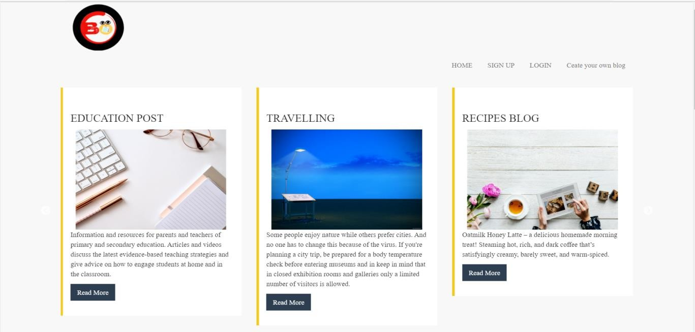

**Home Page:**



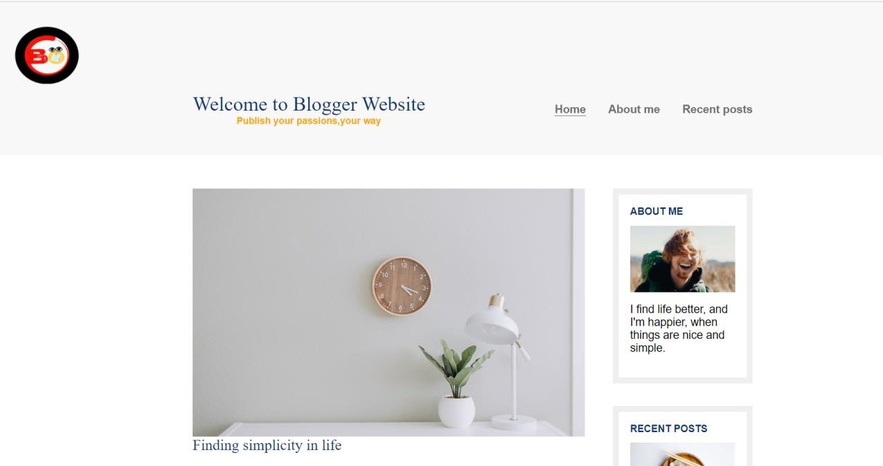

**Login:**

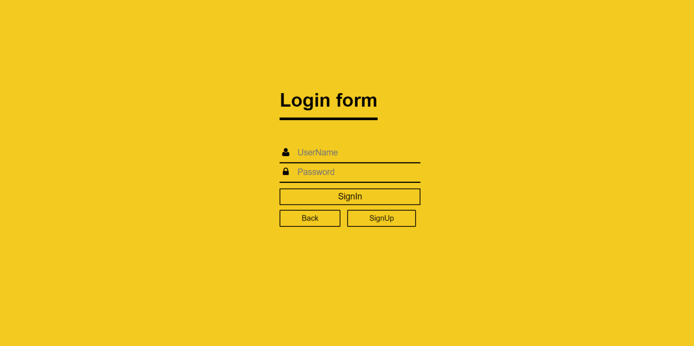



**Signup:**

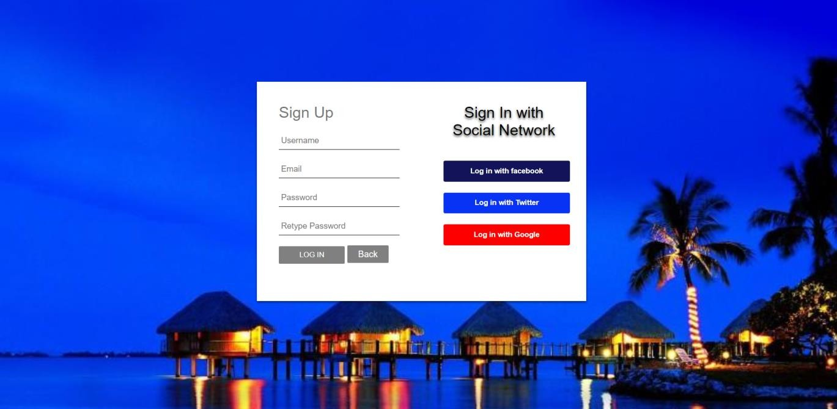

**Create your own blog:**

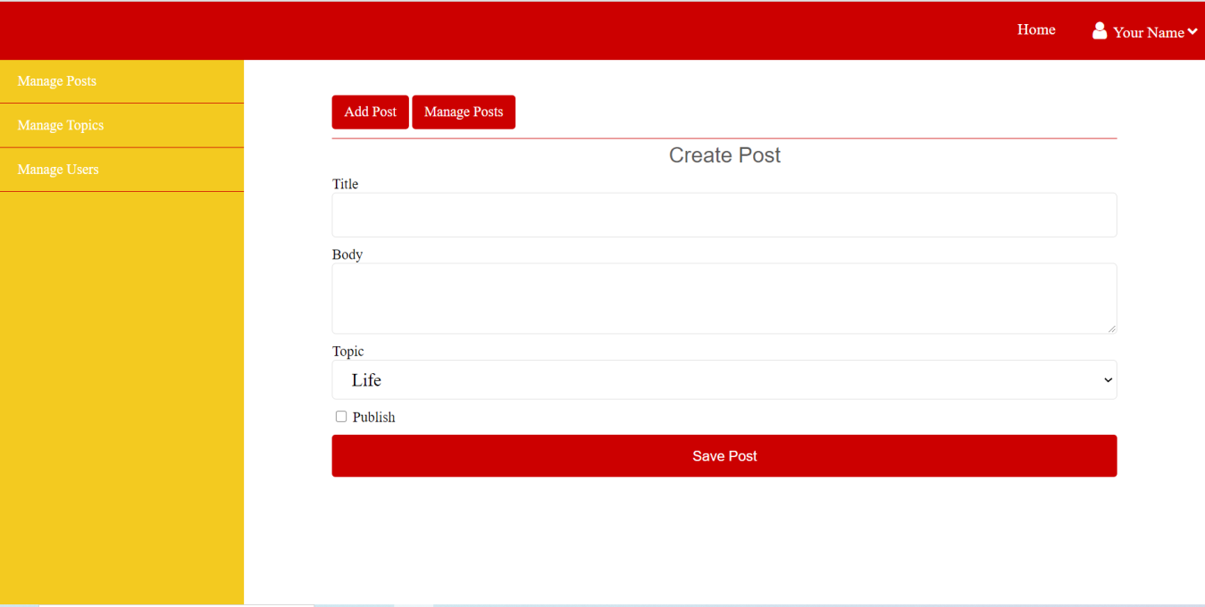



**Manage Post:**



**Manage Topics**

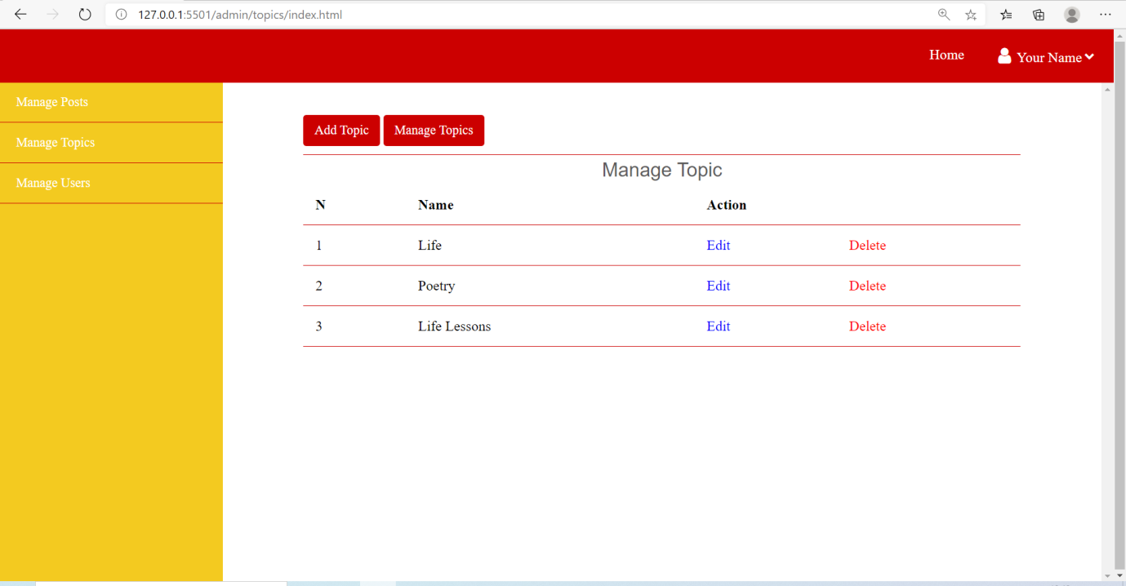



**Manage User**

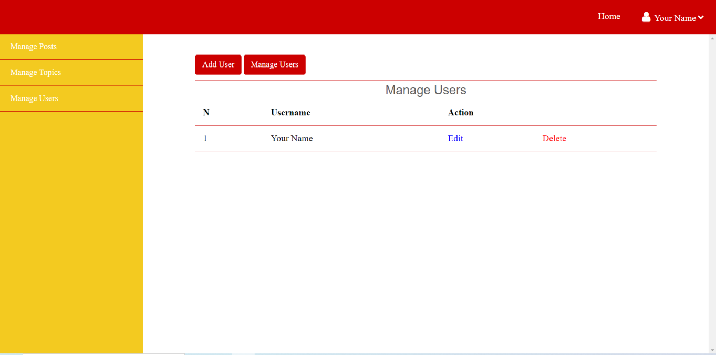



**CONCLUSION**

The project is based on a blog content management on web page designing which is a knowledgeable project for the students. A blog is an opportunity to inspire people and make them see how great your brain is. You should leave your readers energized and leaping out of their chairs, ready to move mountains, make big decisions, or at least try something new.Since the advent of blogs, the number of online journals has significantly increased worldwide. Private bloggers write down their own thoughts and share their ideas and experiences with their readers.We hope the blogging industry will become more diverse with time**.** In particular, we would love to see more representation on this survey in years to come from people of many different ethnicities and countries of origin. In that diversity, the blogging industry will gain perspective and richness that it would otherwise lack and we will all be better for it.